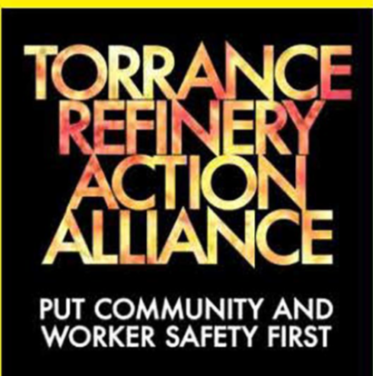
RE: TRAA view of Rule for Chemical Accident Prevention
Date: September 10, 2022
The proposed Accidental Release Prevention Requirements: Risk Management Programs Under the Clean Air Act; Safer Communities by Chemical Accident Prevention fails to protect workers or the community from catastrophic mass casualties from HF and other Highly Hazardous Chemicals (HHC).
TRAA encourages all to communicate to the Environmental Protection Agency (EPA) and President Biden during this month of September, the need to significantly strengthen the proposed RMP Rule to require conversion from these exceptionally dangerous chemicals that can cause mass casualties to vastly safer alternatives.
EPA will be holding virtual public hearings about the proposed rule on the following days. Please select YES when the form asks if you want to make an Oral Comment
- Sept. 26, 2022, 9AM-12 Noon EDT (Register here) Sept 27, 1-4 PM EDT (Register here)
- Sept. 28, 2022, 5PM - 8PM EDT (Register here)

To Submit, written &/or video comments & attachments https://www.regulations.gov/commenton/EPA-HQ-OLEM-2022-0174-0003
Although the EPA recognized the special danger posed by HF use in refineries, tragically the EPA rule does virtually nothing to bring about the conversion to a safer alternative.
The proposed RMP rule includes many good improvements:
- It highlights HF as “extremely toxic” with a subsection on p.75 about HF and put special focus on “chemicals that can cause greater harm to the community “
- It highlights the additional burden for communities that have a high ranking for environmental justice burden and that have multiple facilities with dangerous chemicals near each other.
- It requires facilities with HF to do a Safer Technology Alternatives Assessment to see if there are practical alternatives
- It gives employees some greater participation In the safety process
- It acknowledges the need by people living near these facilities for information
- It reveals that costs for a revamp could be as low as $35 million
- It reveals that significantly lower exposure than had previously been reported, could cause casualties.
All of these TRAA supports.
But the Rule fails miserably to protect the community & workers because:
- It does not provide a pathway for replacement of dangerous chemicals like HF even though safer alternatives are practically available. “EPA contends that the practicability of these potentially safer alternatives are situation-specific…operators are usually in the best position to make these determinations” EPA uses the term “potentially” while even the American Petroleum In Association says there are “commercially proven alternatives”. This is a shocking statement that abandons the EPA’s General Duty to protect the community by leaving the decision to the owners.
- Facilities using chemicals that can cause mass casualties can merely state that it's not practical to convert. California regulation already requires a safer technology alternative assessment for the last five years with little to no effect. Like California, the EPA rule does not require any third-party audit of the refinery’s assessment nor does it require conversion, if the inherently safer technology is practicable.
- It does not consider at all the national security threat of “stationary weapons of mass destruction” – Barack Obama 2006. Despite receiving many statements from nationally recognized leaders on the security concerns from HHCs, there is nothing to require greater security attention for such facilities.
- It does not consider at all the risk from transportation of chemicals capable of mass casualties. The EPA states they collaborate with Depts of Transportation and Homeland Security who have the primary oversight for transportation, there are no provisions for coordination with those departments.
- It does not even require informing the public about the presence of Highly Hazardous Chemicals (HHC) - Individuals in the six mile radius can request information, but no systematic information distribution is required directly to the residents of the surrounding communities about the exceptional dangers of HF.
But due to the exceptional nature of HF, we encourage all to take a quick view of 2 short but gripping videos that apply to all 42 communities near an HF unit:
- About the near-miss in Torrance CA Are schools prepared for a Chemical Release?
- Close-up look at HF release in Philly https://www.youtube.com/watch?v=e0Jg87NFu5k
There is still an opportunity to strengthen this rule to bring about conversion from HF to a safer alternative-
To Submit, written &/or video comments & attachments https://www.regulations.gov/commenton/EPA-HQ-OLEM-2022-0174-0003

EPA will be holding virtual public hearings about the proposed rule on the following days. Please select YES when the form asks if you want to make an Oral Comment
- Sept. 26, 2022, 9AM-12Noon EDT (Register here) Sept 27, 1-4 PM EDT (Register here) Sept. 28, 2022, 5PM - 8PM EDT (Register here)

Please Copy:
- Administrator Michael S. Regan - Regan.Michael@epa.gov
Chair, Whitehouse Council on Environmental Quality Brenda Mallory, Bmallory@whitehouse.gov

- Torrance Refinery Action Alliance (TRAA) info@traa.website

